Chapter
1

Introduction
the Bridge Engineering Tool Kit provides tools for solving bridge engineering problems. These tools range from simple two dimensional shape modeling to high end finite element analysis. This manual describes the design and implementation of the libraries and frameworks in the BETK.

BETK Packages
The Bridge Engineering Tool Kit is organized into several package. Each package provides unique services and solve a different engineering problem. The BETK packages are:
- Engineering Tools
- Material Modeling
- 2D Geometrical Modeling
- 3D Geometrical Modeling
- COGO
- Finite Element Analysis
- Analysis Tools
- Bridge Analysis
- Bridge Modeling
The relationship between the various packages is shown in Figure 1.
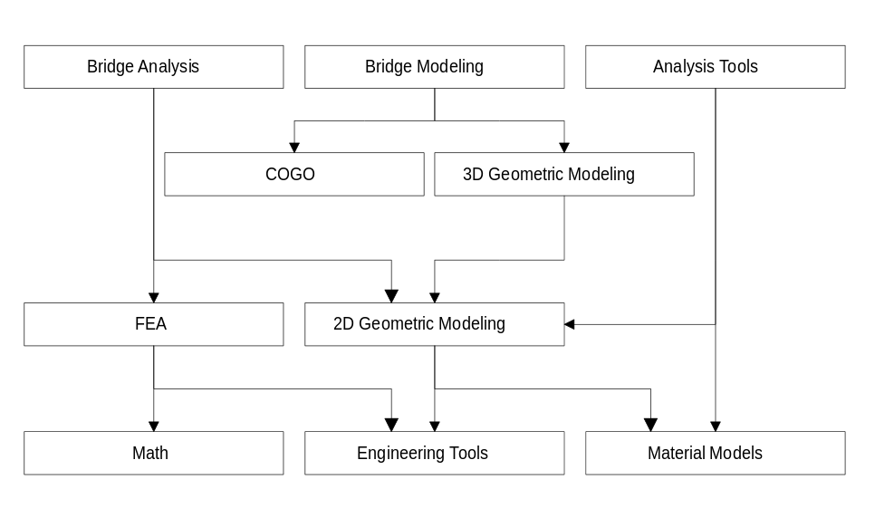
Figure 1

Modeling
One common theme throughout the Bridge Engineering Tool Kit is that of modeling. We use models in computer programs, as well as real life, to approximate and study that which we wish to understand. If money is of no concern, and pin-point accuracy is essential, every bridge would be constructed to exacting standards in a laboratory and thoroughly tested before being constructed in the field and opened to traffic. Obviously, building a prototype of every bridge and testing it prior to building the real bridge is simply not practical. The next best thing is to create models of the bridge and learn all we can before construction begins. The most detailed models might represent the bridge at an atomic level, more general models might represent the bridge from a macro perspective. Modeling the structure from these radically differing perspectives is abstraction. Abstraction is the elimination of the irrelevant and the amplification of the essential. The Bridge Engineering Tool Kit provide two types of models; Product Models and Analytical Models.
Product models are used to capture the physical attributes of a real bridge and its components. Product models act as abstract surrogates for real structures. Generally, product models capture and manage bridge/engineering domain concepts, such as span lengths and reinforcement layout.
Analytical models are used to simulate the behavior of the real bridge or to compute some property of it . In order for them to be useful for a wide range of problem domains, analytical models are typically blind to bridge/engineering domain concepts. Their abstractions focus on the representation of an engineering problem and its solution and not on the domain that contains the problem. For example, a finite element model is an analytical model of a structure. The analytical model is concerned with elements, nodes, connectivity, loads, and resulting forces. The analytical model does not care if a particular element in the model represents a column, girder, or roadway slab.
It is not uncommon to create several analytical models for a given product model. For example, consider a reinforced concrete beam. From a product model of the beam, we can build an analytical model to compute transformed section and elastic stiffness properties. We could also build a uniaxial bending analysis model for a section in the beam to determine the ultimate moment capacity at that section.
In general, neither the product models nor the analysis models have graphical user interface elements. These models typically don’t respond directly to user input events like mouse movement or keyboard presses. Models usually supply static rendering capabilities. Direct manipulation of these models in an interactive environment is more conveniently handled by a framework designed to provide such functionality. Often times a graphical display object in a direct manipulation framework will delegate its rendering implementation to a draw method in an element of the product or analysis model. For example, in a shape modeling program, the display object could implement its draw method by simply calling the draw method of the gm2dShape it represents.

Model Builders
The product and analytical models in the BETK are completely de-coupled. Clients can use one or the other or both, it all depends upon the problem that is being solved. Since it is common to build analytical models from product models, the BETK provides several builder objects that extract (or abstract) data from product models and construct analytical models. The builder objects map product domain information and behaviors to the analytical model domain. After the builder objects construct analysis models, it is up to the client developer to make use of the model by extracting information that is meaningful in the implementation of a specific application.
An example of a model builder is a biaxial analysis model builder. This builder gathers information from a reinforced concrete beam element of a product model and creates a biaxial analysis model. The client programmer can then use the analysis model to compute a moment interaction surface for the concrete beam.

Engineers
In the real world engineers solve problems. Likewise, in the BETK, engineer objects solve specific engineering problems. Engineer objects are one level of abstraction above model builders. An example of an engineer is a beam capacity engineer. A beam capacity engineer takes a product model of a reinforced concrete beam and computes its bending capacity. The engineer hides all the details of creating analytical models and interpreting results from the analytical model.

Martin, Robert C., Designing Object-Oriented C++ Applications Using The Booch Method, Prentice-Hall, 1995, pg 9

